Project Title:- Built-in Self-Test Technique for Diagnosis of Delay Faults in Cluster-Based Field Programmable Gate Arrays.
Date – 08-04-2026
1. How does it solve a problem in the industry?
The Industry Problem: As semiconductor companies (like Intel, AMD, and TSMC) shrink transistors down to 3nm and 5nm, chips are becoming incredibly susceptible to process variations and aging effects (like transistor wear-out). Because of this, wires don't just "break" (stuck-at faults) anymore—they degrade and get slower.
Your Solution: Standard testing machines (ATE) cost millions of dollars and struggle to test chips at their maximum gigahertz speeds. By embedding a Built-In Self-Test (BIST) directly into the FPGA architecture, the chip tests its own routing pathways at full operating speed. This saves hardware companies massive amounts of testing time and money during production.

2. How is your project different from others?
Most standard VLSI university projects stop at Fault Detection—they build a circuit, inject a fault, and show a waveform proving the system noticed the error.
Your project goes a step further by implementing Fault Diagnosis.
- Standard Project: "There is a delay fault somewhere in the chip."
- Our Project: "By cross-referencing overlapping test configurations, we deduce that the delay fault is specifically located in the routing matrix connecting Cluster 4 to Cluster 7."
We aren't just building fault detection; we are building a system that points to the exact location the fault is in.

# Ways to check the exact location of fault.
1. The Deductive Method: Overlapping Path Analysis
How it works: You configure the BIST to test a specific path (e.g., passing a signal through Switch A, Wire B, and Switch C). Then, you reconfigure it to test overlapping paths (e.g., Switch X, Wire B, and Switch Y).
The Logic: You create a matrix of passes and fails.
- If Path 1 (A + B + C) Fails
- If Path 2 (X + B + Y) Fails
- If Path 3 (A + Z + C) Passes
- Deduction: Since Path 3 passed, A and C are healthy. Since Paths 1 and 2 both failed and share only Wire B, Wire B is the location of the delay fault.
2. The Dictionary Method: Signature Analysis
This method relies on creating a unique "fingerprint" for every possible fault before you even test the physical chip.
- How it works: In your Output Response Analyzer (ORA), you use a circuit called a MISR (Multiple Input Signature Register). A MISR compresses all the test outputs into a single hex code (a "signature").
- The Process:
  - First, in your Vivado simulation, you artificially inject a fault at every single location, one by one, and record the resulting signature. This creates a "Fault Dictionary."
  - During the actual physical test, the hardware generates a signature.
  - You look up the hardware signature in your Fault Dictionary to find the exact coordinate of the fault.
3. The Modern Method: Machine Learning (Your "X-Factor")
As chips become massively complex, the overlapping logic and fault dictionaries become too large to compute manually. This is where you can bring in your software stack.
- How it works: You run hundreds of simulated BIST sessions, injecting random delay faults across the chip and recording the massive arrays of 1s (fails) and 0s (passes).
- The Process: You use this data to train a classification algorithm (like a Random Forest or Support Vector Machine in Python using scikit-learn).
- The Result: When the real FPGA runs its test, it feeds the raw pass/fail array into your ML model, and the model instantly predicts: "There is a 95% probability the delay fault is in Cluster 4, Routing Matrix East."

Week - 3
3.Testing method
Have three main components:
- A Test Pattern Generator (TPG) that creates the input signals,
- A Block Under Test (BUT) which is the hardware being checked
- An Output Response Analyzer (ORA) that checks if the final output matches what is expected.

3.1 Testing the LUTs
Problem: In older testing methods, engineers would chain several LUTs together, send a signal through, and measure how long it took to come out the other side. The problem is that the connections between the Test Pattern Generator (TPG) and the LUTs use different types of wires—some are "long wires" and some are "local wires". Because different wires have different natural speeds, it was impossible to tell if a detected delay was caused by a faulty LUT or just a slow wire.
- The Long Wires (The TPG to BUT Connection): The Test Pattern Generator (TPG) is an independent block that generates the test signals. To deliver these signals across the chip to the actual Block Under Test (BUT), the routing must traverse a larger physical distance. Therefore, the connections coming from the TPG into the first LUT of the chain heavily rely on the long wires
- The Local/Short Wires (The LUT to LUT Connection): Inside the Block Under Test (BUT), the authors are chaining multiple Look-Up Tables (LUTs) together (connecting the output of one to the input of the next). Because these LUTs sit right next to each other within the local Configurable Logic Blocks (CLBs), these internal chain connections primarily use the local wires. 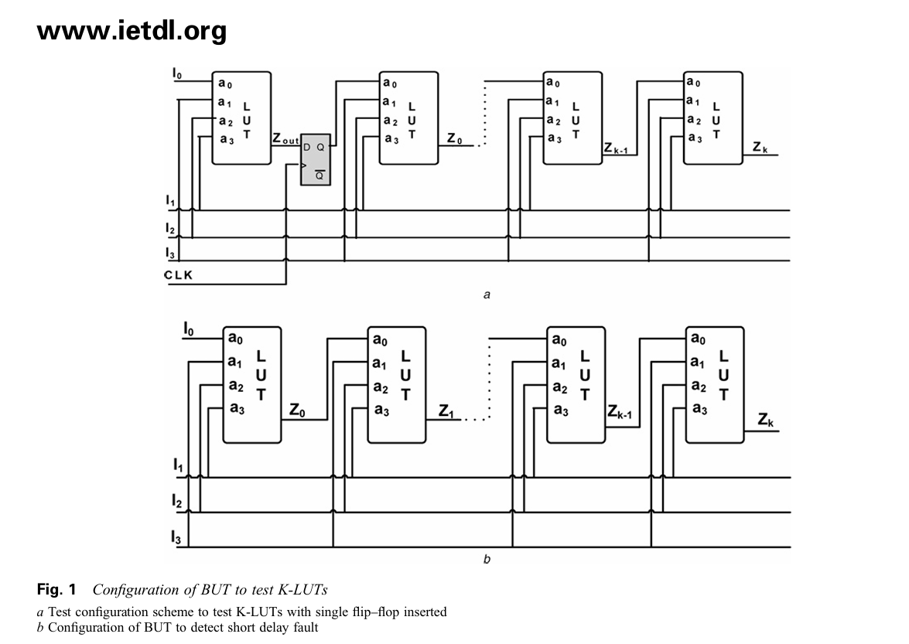

In figure a:
- The clock time of the D Flip Flop is generally more than the normal because if there is any delay due to the long wire then the extra increase in clk time period absorb that dealy and transfer towards the next LUTs. And if there is no delay fault in the further LUTs then it provide the correct result.
- Overall figure a measure the fault in LUTs by avoiding the fault due to long wire.
In figure b:
- It help to measure the delay due to long wire
- The wire delay travels through the whole system uninterrupted, causing the final output to arrive late.

Week 4
Testing of Multiplexers: -
Focus on the MUX inside the CLB
Question: - Why we cannot directly increase the input of the LUTs?
Answer: - an n-input LUT operates by storing the values of the implemented function in exactly 2^{n} SRAM (memory) cells
Because of that 2^n rule, the physical size of the memory required to build a LUT blows up incredibly fast:
- A 4-input LUT requires 2⁴ (16) SRAM cells.
- A 5-input LUT requires 2^5 (32) SRAM cells.
- A 6-input LUT requires 2^6 (64) SRAM cells.
- An 8-input LUT requires 2^8 (256) SRAM cells.
if a programmer only needed a simple 2-input or 3-input logic gate, the vast majority of those expensive SRAM cells would sit completely empty and wasted.
{NOTE: - Modern FPGAs have actually advanced to the point where they do physically use 6-input LUTs as their baseline, though the exponential space problem still applies if they go any larger}

Step 1: The "Mega-MUX" Setup.
The user-defined multiplexers (like MUXF5, MUXF6, MUXF7, MUXF8) together to build one massive multiplexer, such as a 16:1 MUX. This is shown in below Figure
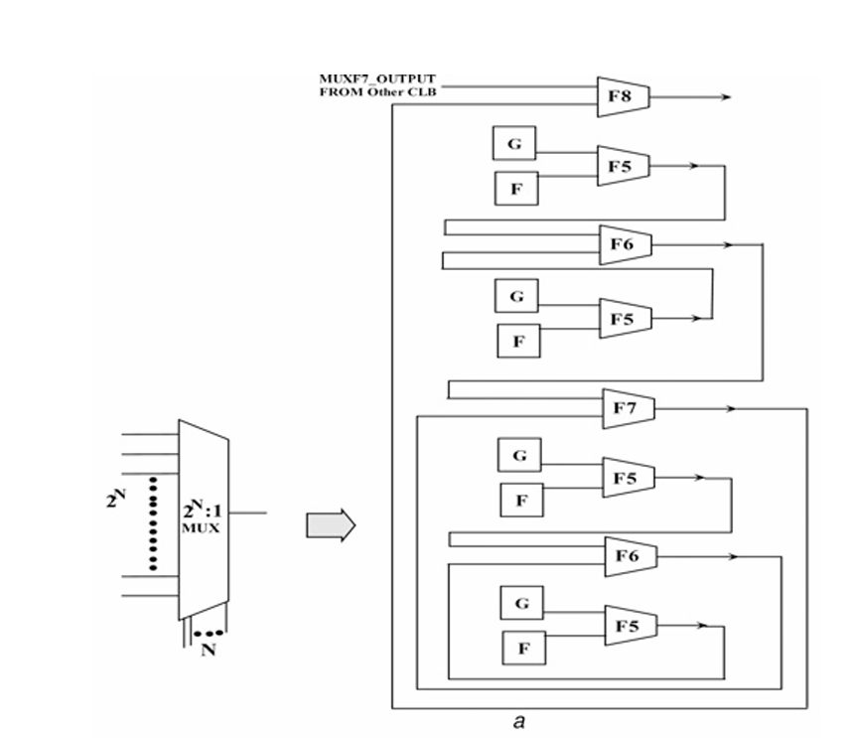
Step 2: Testing the Input Lines (The Data Tracks)
To make sure the physical data paths can carry a signal without delay, they test them one at a time
- The Action: They use the select lines to open exactly one input path to the output.
- The Condition (The Test): send a signal transition right through it by applying a complementary (opposite) value. This means they quickly flip the input from a 0 to a 1 (to test for a Slow-to-Rise fault), and then from a 1 to a 0 (to test for a Slow-to-Fall fault)
- The Math: If a multiplexer has a ratio of 2^{n}:1 (meaning it has 2^n input lines), they have to do this for every single input. Therefore, it requires 2^n distinct test vectors to thoroughly check all the input lines.

Step 3: Testing the Select Lines
- The Action: To test N, select lines, we use a specific sequence of test vectors that behaves like a "Johnson Counter". A Johnson Counter is a digital circuit that flips only one bit at a time (for example, 000 100 110 111). This ensures they are only testing the speed of one "lever" transitioning at a time.
- The Condition (The Test): While the select lines are changing via this Johnson Counter sequence, the input lines are fed the complementary value of that selection to guarantee a measurable change occurs at the output.

Step 4: Finding the Faulty MUX (Divide and Conquer)
At the end of this massive chained MUX is an Output Response Analyzer (ORA). The ORA expects the signal to arrive at a very specific time.
- The Solution: It use the "divide and conquer" rule and reprogram the chip to break the giant 16:1 MUX into two separate 8:1 MUXes and run the test again. Until get the faulty one

Testing the Athematic Logic
They are the circuits inside the Configurable Logic Block (CLB) responsible for doing math, specifically addition.
We have to test two different physical paths:
- Sum
- Carry
Steps to execute the test:
- The Setup (The Adder Chain)
  - Configure the Block Under Test (BUT) to act as a "look ahead carry adder".
- Identifying the Paths (Figure): Inside this setup, they are testing two specific physical routes:
  - The Sum Path: This route handles the main addition and is built using the LUT and an XOR gate.
  - The Carry Path: This route handles the carry-over bits and is built using an AND gate and a specialized multiplexer called a "MUXCY".
- The Step-by-Step Testing Process: They test the circuits by forcing a transition (a sudden switch from 0 to 1, or 1 to 0) to "ripple" through the gates.
  - Initialization:
    - They first apply Vector 1, setting all inputs (G2, F1, F2, Cin) to '0'. This flushes the system and initializes all paths to a baseline '0' state.
  - Testing the Sum Path (Low-to-High)
    - They apply Vector 2, changing F1 to '1' and Cin to '1'.
    - This specific combination forces a '0' to '1' transition (a rising edge) to travel specifically through the path: Cin MUXCY Sout. If Sout takes too long to change to a '1', the system has detected a Slow-to-Rise delay fault in the sum logic.
  - Testing the Sum Path (High-to-Low)
    - They apply Vector 3, setting G2 and F1 to '1', but flipping Cin back to '0'.
    - This forces a '1' to '0' transition (a falling edge) through that exact same path, testing for a Slow-to-Fall delay fault.
  - Testing the Carry Path: In digital logic (specifically in an adder), a carry bit can either be "propagated" (passed along from the previous stage) or "generated" (created by the current data inputs). So test vectors isolate and test both of these scenarios:
    - After resetting the system again with all '0's (Vector 4), they use Vectors 5 through 8 to target the Cout terminal.
    - Testing the "Propagate" Route (Vectors 5 and 6):
      - This tests the physical path where a carry bit coming from a previous addition (Cin) travel through the multiplexer to the output (Cin MUXCY Cout). Vector 5 applies specific inputs to force a low-to-high transition along this route, while Vector 6 tests the exact same route for a high-to-low transition.
    - Testing the "Generate" Route (Vectors 7 and 8):
      - This tests the alternative path where a new carry bit is created by the data inputs themselves (F1 and F2) and sent to the output (F1F2 MUXCY Cout). Vector 7 forces a low-to-high transition on this specific path, and Vector 8 forces a high-to-low transition.
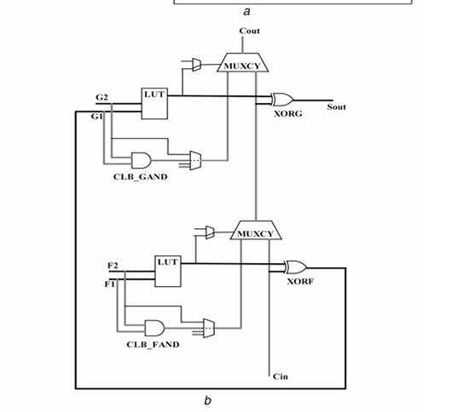

Week – 5
BUT Configuration for testing of D Flip-Flop
Route A: Data coming from the logic brain (the LUT) right next to it.
Route B: Data coming directly from outside wires, bypassing the LUT entirely.

Test 1: Testing the "Direct Route" and the Clock (Figure c): - This test ignores the LUTs and focuses on the flip-flops and the "clock" wires.
- The Setup: They chain a bunch of flip-flops together in a line. they program the flip-flops to act as "transparent latches." This means when the clock signal is turned ON, the doors to all the memory boxes swing wide open, letting data flow straight through from one to the next without stopping.
- The Action: They start by clearing all the flip-flops to zero and keeping the clock OFF. Then, they suddenly snap the clock ON (a high input).
- What it Catches: When the clock ON, data rushes through the entire chain. If the final signal arrives late, it means the wires that deliver the clock signal (the clock distribution network) are too slow, or the flip-flops themselves have a delay fault.
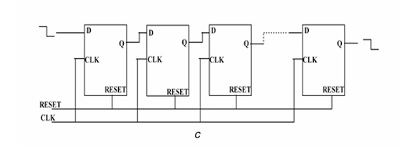
Test 2: Testing the "LUT to Memory Route" (Figure d): - Checks the specific, tiny wire that connects the output of the LUT into the input of the flip-flop.
The Setup: Pair a LUT and a flip-flop together, and then chain N number of these pairs in a long line. To make the test easy to measure, they program the LUT to act like a simple "AND gate". By making it an AND gate, the LUT doesn't do any complex math; it just takes the signal and passes it straight through to the flip-flop.
The Action: They send a signal transition (flipping a 0 to a 1) into the start of the chain. The signal hops from LUT Flip-Flop next LUT next Flip-Flop.
What it Catches: This specifically proves whether the physical wire connecting the logic generator to the memory storage is fast enough. 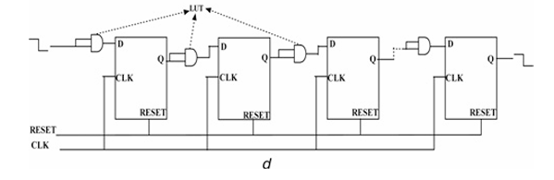
BUT configuration for testing Multiplier
In Xilinx Virtex architectures, these are specialized hardware blocks built directly into the silicon, specifically designed to multiply two 18-bit numbers together to produce a large 36-bit result.
According to 2^{n} rule here, we would have to run 2³⁶ tests—which is over 68 billion test combinations, that take impractical amount of time and memory.
That’s why we focus strictly on forcing transitions through the longest physical wires inside the block.
The Setup:
- configure multiple identical multiplier blocks across the chip to receive the exact same inputs and perform the exact same math problems simultaneously.
- The 36-bit answers from all these multipliers are fed directly into an Output Response Analyzer (ORA). The ORA acts as a referee, comparing the outputs to ensure they all arrive at the exact same picosecond.
The Test:
- Testing the "Adder Tree”: - The Test Pattern Generator feeds specific numbers into the multiplier designed to force every single adder in that tree to do work. They want to force the internal wires to flip from a 0 to a 1, and back to a 0.
- Targeting the "Critical Path": - Inside this massive tree of adders, some physical electrical paths are very short, while others are very long and twisty.
  - Strategy is simple: If we can prove that a signal can successfully speed down the longest, hardest path in time, they can safely assume the shorter, easier paths are working perfectly too. They don't need to test them all.
  - What the Patterns Look Like:
    - The "Walking 1": Imagine sending a number that is mostly zeros with a single one (like 00001). On the next clock tick, they move it over (00010), then again (00100). This acts like a spotlight, forcing one specific wire to flip ON and OFF sequentially across the entire block.
    - Alternating Bits: It might send 101010 and immediately follow it with 010101. This forces massive amounts of gates to flip their state simultaneously, acting as a supreme stress test for the speed of the silicon.
By feeding these specific, stressful patterns into the multiplier, it can guarantee the physical hardware is fast enough without having to calculate every possible math equation in the universe.

BUT configuration for testing DSP
It is a massive, complex macro-component. It doesn't just multiply; it can also accumulate, add, subtract, and pipe data through built-in registers.
What is Inside the DSP Block Under Test?
- The Multiplier: Handles the core 18 × 18-bit multiplication.
- The Adder/Subtracter/Accumulator: Sits right after the multiplier to add or subtract the multiplication result from previous cycles.
- Pipeline Registers: Storage registers placed at the input, multiplier stage, and output to help data flow quickly at high clock speeds.
The Setup:
- During this test, lock the DSP block into a configuration that forces all internal registers to be turned ON. They want the signal to stop at every single checkpoint because they need to prove that the tiny doors on those registers can open and close fast enough under pressure.
- To make the test predictable, they temporarily turn off the "running total" feature. They configure the block so it only performs the multiplication and passes that number straight through the adder without adding old data to it. This ensures the testing system knows exactly what answer to expect at the end of the line.
The Test:
- They take several identical DSP blocks across the chip, configure them all into this exact same assembly-line setup, and feed them the exact same tricky math patterns simultaneously.

WEEK – 6
Output response analyser (ORA): - It evaluates circuit timing by comparing parallel block outputs, detecting timing mismatches as transient pulses.
Step 1: - Parallel Signal Comparison
- Feed the outputs from two identical Blocks Under Test (BUT 1 and BUT 2) simultaneously into a primary 2-input XOR gate. If both blocks transition at the exact same picosecond, the XOR gate outputs a steady 0 (fault-free state).
Step 2: - Transient Mismatch Detection
  - When a physical defect (like a Slow-to-Rise fault) causes BUT 1 to lag behind BUT 2, the XOR gate sees mismatched inputs (1 and 0). It fires a high voltage pulse (X) for the exact duration of the delay gap. Verify detection by observing the transient pulse width matching the physical signal lag.
Step 3A: - Pass/Fail Error Latching (Fig. a)
  - For simple fault screening, route the pulse X into the clock input of cascaded T flip-flops (set to toggle mode). The first pulse toggles the internal state T, which drives the final output T_{out} High (1). This permanently locks the failure in memory even after the transient pulse vanishes.
Step 3B: - Delay Measurement & Digitization (Fig. b & c)
  - For quantitative diagnosis, route the mismatch signal into a feedback XOR oscillator. During the delay window, the oscillator outputs a rapid clock pulse burst X₀ whose total pulse count is directly proportional to the delay time. These pulses increment an n-bit and k-bit counter chain.
Step 4: - Diagnostic Readout & Verification
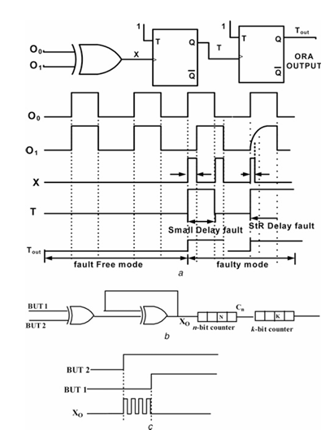
  - Freeze the test clock once the Test Pattern Generator completes its sequence. Scan out the final ORA states to verify results: a 0 on T_{out} confirms a pass, a 1 confirms a timing fault, and the binary value in the counter chain yields the exact magnitude of the delay fault.

Test Pattern Generator (TPG)
Part 1: - Test Pattern Generator (TPG) Architecture & Transition Generation
Que- Why Single Patterns Fail for Delay Faults
Ans- To catch the Slow to Rise and Slow to Fall we require the sharp transition in the input, so that they force the BUT for the transition in their state.
We must generate a two-pattern vector pair (V1 and V2)
  - Vector 1 (V1 - Initialization Vector): Charges or discharges the target internal nodes to a stable baseline state (0 or 1).
  - Vector 2 (V2 - Launch Vector): Applied immediately on the next clock edge to force a sharp transition (0 1 or 1 0) along the target path.

Hardware Structure of the TPG
Because the TPG must be synthesized directly onto the FPGA's Configurable Logic Blocks (CLBs), it is designed for minimal hardware overhead using three primary structures:
Modified Linear Feedback Shift Registers (LFSRs): Generate pseudo-random patterns across wide busses. For delay testing, standard LFSRs are modified with adjacent-bit flip-flops to ensure V1 and V2 differ by specific bit transitions without creating illegal input combination
Johnson Counters / Shift Registers: Used for structural components like Multiplexers and LUT arrays. They produce deterministic patterns such as "Walking 1s" (0001 0010 0100 1000) or alternating bit streams (1010 0101).
Shadow Registers: Store V2 in parallel while V1 is loaded, allowing V2 to be driven into the Block Under Test (BUT) on the very next clock cycle without waiting to shift data in serially.
Part 2: - At-Speed Clocking and Timing Synchronization
It details how the BIST architecture generates, controls, and synchronizes ultra-fast clock signals inside the FPGA to catch these sub-nanosecond delay faults.
The Clock Generation Network (PLL / MMCM)
- PLL/MMCM (Mixed-Mode Clock Manager): Takes a stable reference clock from the board and multiplies it up to the target operational frequency (e.g., 300 MHz–500 MHz)
- Glitchless Clock MUX (BUFGCTRL): Switches safely between two clocks without creating false voltage spikes (glitches) that could accidentally trigger the ORA flip-flops:
  - Slow Clock (CLK_{slow}): Used for loading initial test configurations and reading out final ORA counts.
  - At-Speed Fast Clock (CLK_{fast}) -enabled only during the actual BIST execution window.

The Math of At-Speed Testing
For a path inside a Block Under Test (BUT) to pass the speed test at a clock period of $T_{\text{clk}}$, it must satisfy the setup timing inequality:
T_{prop} + T_{setup} + T_{skew} <= T_{clk}
Where:
      - T_{prop} = Physical propagation delay through the gates and wires of the BUT.
      - T_{setup} = Setup time requirement of the ORA capture flip-flop
      - T_{skew} = Clock arrival time difference between the TPG launch flip-flop and the ORA capture flip-flop.
      - T_{clk} = At-speed clock period (T_{clk} = 1/f_{max} )

Launch and Capture Timing Sequence
To apply a two-pattern test (V1 V2) and measure the output at full speed, the BIST controller uses a precise 2-Clock Burst Protocol:
- Cycle 0 (Initialization): V1 is driven by the TPG into the BUT. The path settles to a known initial state (0 or 1)
- Cycle 1 (Launch Edge): The first high-speed clock edge hits the TPG. The TPG instantly launches V2, causing a rising or falling transition wave front to travel down the BUT.
- Cycle 2 (Capture Edge): Exactly one clock period T_{clk} later, the second high-speed clock edge hits the ORA.
  - If the transition arrived before Cycle 2, the ORA reads V2’s expected outcome (PASS).
  - If the transition was delayed by even a few hundred picoseconds, the BUT output is still stuck at V1's value when Cycle 2 arrives (FAIL).
Clock Skew Mitigation
If the clock signal reaches the TPG flip-flop earlier than the ORA flip-flop, the test will be unfair—giving the BUT extra time to complete its transition (masking a real fault). If the clock reaches the ORA earlier, it will cause a false fail on a healthy block.
To eliminate clock skew (T_{skew} approx 0)
- Global Clock Buffers (BUFG): TPG, BUT, and ORA blocks are all routed through symmetrical primary clock trees, ensuring the clock wavefront propagates at uniform speed across the FPGA array.
- Symmetrical Floorplanning: The TPG, BUT, and ORA are placed in directly adjacent physical logic clusters so the clock distribution path lengths are identical.

Part 3: Multi-Session Ping-Pong Reconfiguration & Fault Isolation
Que - Who Tests the Tester?
Ans- BIST relies on the FPGA's internal CLBs to synthesize both the TPGs and ORAs, a fundamental deadlock arises what if the fault is in the tester means if an ORA flags a failure when comparing two BUTs , the fault could exist inside any of BUTs of inside the TPG/ORA itself
To break this deadlock without adding dedicated external test hardware, the BIST controller employs a Multi-Session Ping-Pong Reconfiguration strategy. The FPGA fabric is reprogrammed across multiple sequential test sessions, systematically swapping the roles of tester and tested logic.

The Three-Session Ping-Pong Execution Protocol
- Session 1 (Even Columns = BUTs, Odd Columns = Testers):
  - Even-numbered CLB columns are configured as BUTs.
  - Odd-numbered CLB columns are configured as TPGs and ORAs.
  - Result: 50% of the logic array is thoroughly evaluated for delay faults using the remaining 50% as testing infrastructure.
- Session 2 (Odd Columns = BUTs, Even Columns = Testers):
  - Even-numbered CLB columns are configured as TPGs and ORAs.
  - Odd-numbered CLB columns are configured as BUTs.
  - Result: The remaining 50% of the logic array is tested using logic blocks that were proven 100% fault-free in Session 1.
- Session 3 (Interconnect & Routing Matrix Orientations):
  - TPGs and ORAs are repositioned diagonally or at opposite channel ends.
  - Test patterns are driven across global routing lines, inter-cluster switch matrices, and carry chains.
  - Result: Catches delay faults on long global wires that were used merely as static pass-throughs during local CLB testing in Sessions 1 and 2.

Fault Localization Logic Matrix
To pinpoint the exact failing block, the host system performs a set intersection analysis on the binary Pass/Fail matrix produced across consecutive sessions.
Suppose, Session 1, BUT_{A} is paired with BUT_{B} against ORA₁. In Session 2, BUT_{A} is reconfigured and paired with a different neighbour, BUT_{C}, against ORA₂, and in Session 3 BUT_{B} paired with BUT_{C}.
So, by using the result from these three ORAs will find the exact defective BUT

Limitation and Engineering Gaps of this Base Method
- JTAG Reconfiguration Time: Downloading three complete bitstreams for Sessions 1, 2, and 3 accounts for over 95% of the total test time. Full bitstream reloads are prohibitively slow for large-scale modern FPGAs.
- Power Droop: Unconstrained high-frequency switching during at-speed TPG vector generation causes high simultaneous switching noise (SSN) and core voltage droop. This artificial voltage drop slows down gates, causing false-positive delay failures on healthy logic.
- PVT (Process, Voltage, Temperature) Sensitivity: Fixed frequency thresholds fail to distinguish between actual manufacturing defects (like partial opens) and ambient thermal or voltage fluctuations during test execution.
- Symmetric Fault Blind Spot: If two identical adjacent BUTs suffer from the exact same delay magnitude due to a localized die defect, the XOR stage produces a false pass during that session.

Current Commercial Standards
Modern industry BIST relies on Scan-Based Logic BIST (LBIST) with On-Chip Clocking (OCC) and In-Situ Critical Path Monitors (CPMs) embedded directly into operational silicon, rather than manual CLB-level tile reconfigurations.

Scan-Based LBIST with On-Chip Clocking (OCC)
Instead of building extra test hardware around logic blocks, LBIST reuses the chip’s existing internal flip-flops by linking them together into a long chain called a scan chain.
- Step 1: Slow Scan Loading. A low-speed external tester shifts a test pattern of 1s and 0s into the chip's internal flip-flops one bit at a time, loading the initial state into every register.
- Step 2: At-Speed OCC Burst. The OCC block takes over and fires a precise two-pulse burst from the chip’s fast internal clock (PLL):
  - Launch Pulse: The first flip-flop drives a transition (0 1 or 1 0) down the logic path.
  - Capture Pulse: One high-speed clock period later, the receiving flip-flop captures the incoming result.
- Step 3: Slow Readout. The OCC switches back to the slow clock, shifting the captured data out to check if the signal arrived before the capture pulse.

In-Situ Critical Path Monitors (CPMs)
"In-situ" means "on-site." Rather than stopping the chip to run an offline test, CPMs are tiny timing sensors built directly alongside the chip's fastest operational paths while it runs real applications.
- Shadow Registers: A CPM places a secondary register right beside the main operational register. This shadow register samples the incoming data signal slightly before the main clock edge.
- Early Warning Detection: If heat, supply voltage drop, or transistor aging slows down a signal, it will hit the shadow register's sampling window. The CPM flags a warning signal.
- Proactive Defence: The chip receives a warning before an actual functional crash occurs, allowing the system to lower its operating frequency or raise its voltage dynamically.

